PI Calculation using Serial, MPI, and OpenMP

1. Problem Description
In this assignment, I implemented three different versions of a program to approximate the value of PI using numerical integration. The goal was to compare a serial implementation with parallel implementations using MPI and OpenMP.
The value of PI was approximated using the midpoint rectangle method with N = 100,000 iterations.

2. Approach
For the serial version, I used a simple loop that computes the sum of all iterations one at a time on a single processor. I used this version as the baseline for performance comparison.
For the MPI version, I split the total number of iterations across multiple processes using a cyclic distribution. Each process calculates a local sum, and then all local sums are combined using MPI_Reduce to get the final result.
For the OpenMP version, I used a parallel for loop with a reduction clause. This allowed multiple threads to compute parts of the sum at the same time while safely combining the results at the end.

3. Results

Compilation

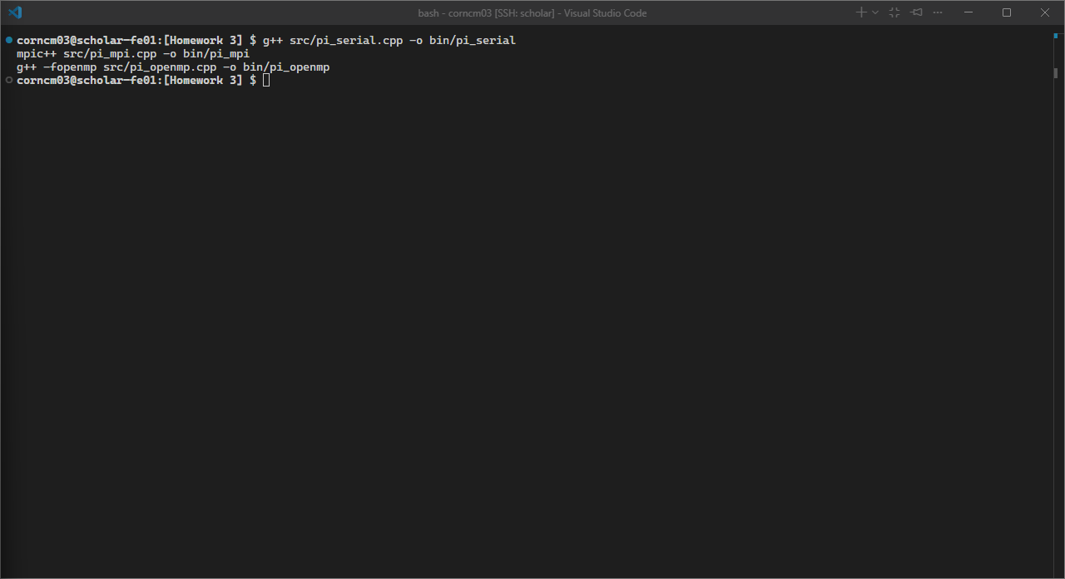
Figure: Homework 03 Screenshot 01-Compile Commands Completed

Serial Execution

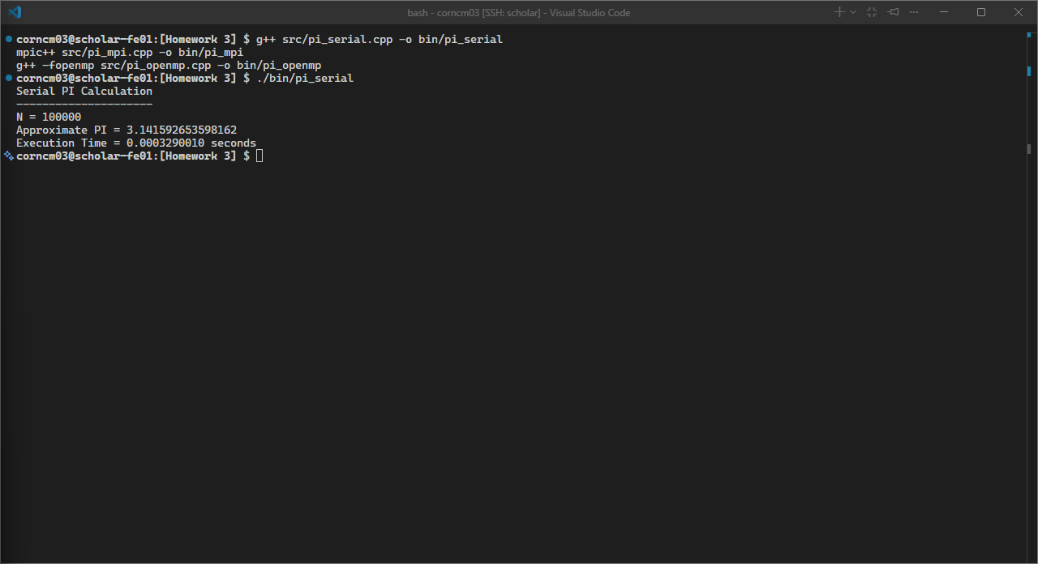
Figure: Homework 03 Screenshot 02-Pi Serial Run

MPI Execution

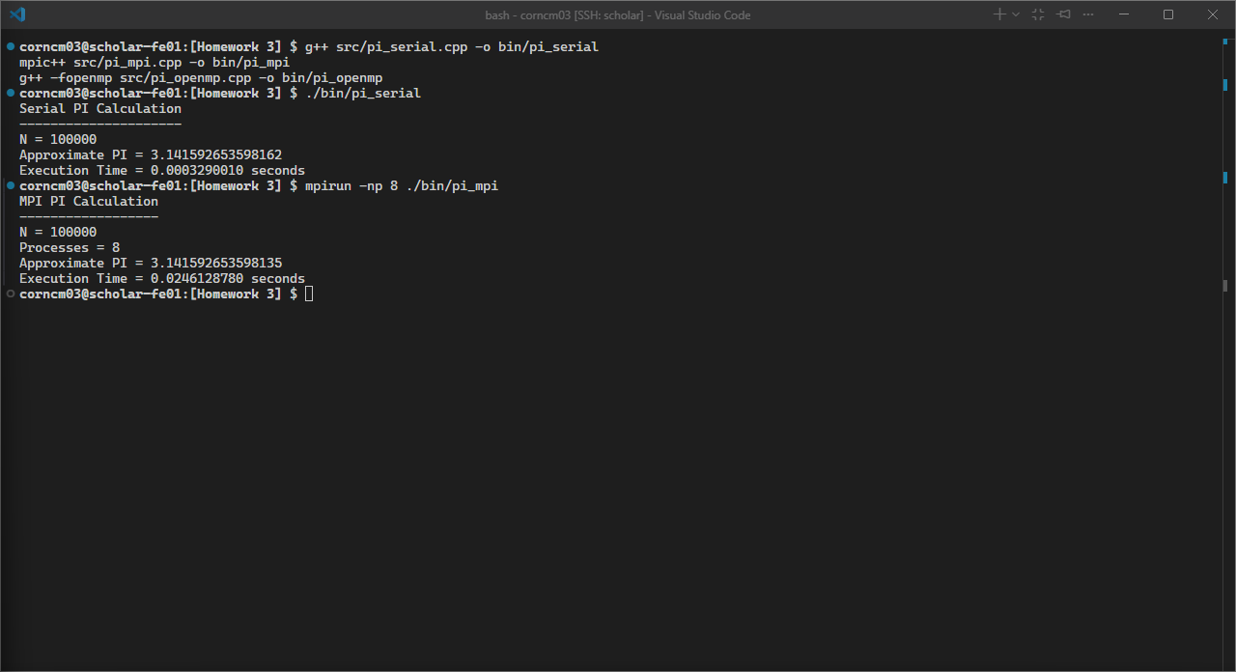
Figure: Homework 03 Screenshot 03-Pi MPI 8 Run

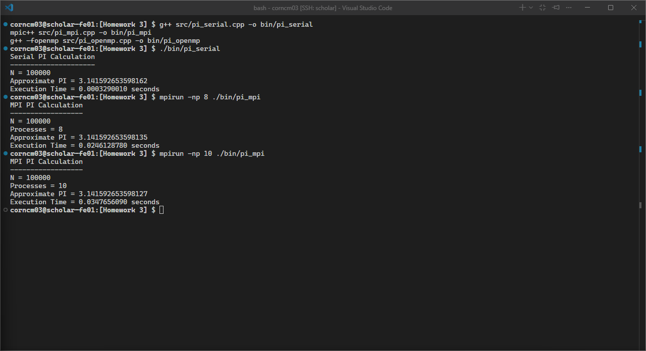
Figure: Homework 03 Screenshot 04-Pi MPI 10 Run

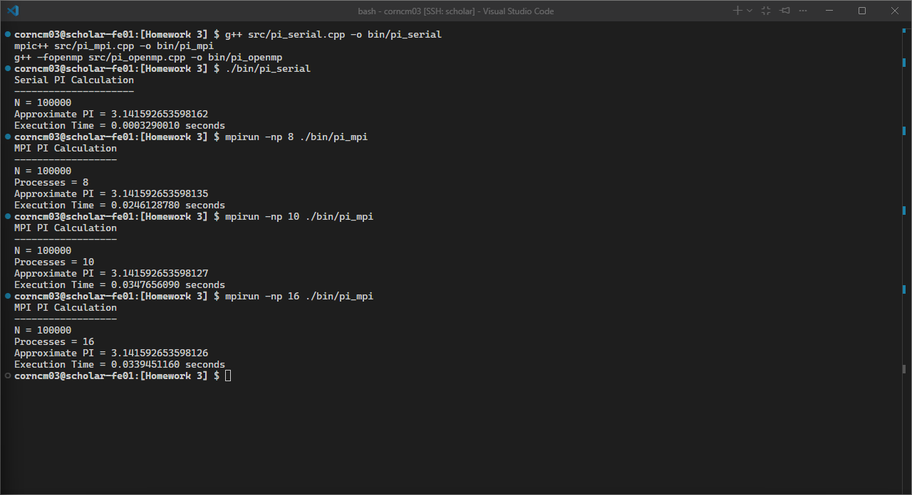
Figure: Homework 03 Screenshot 05-Pi MPI 16 Run

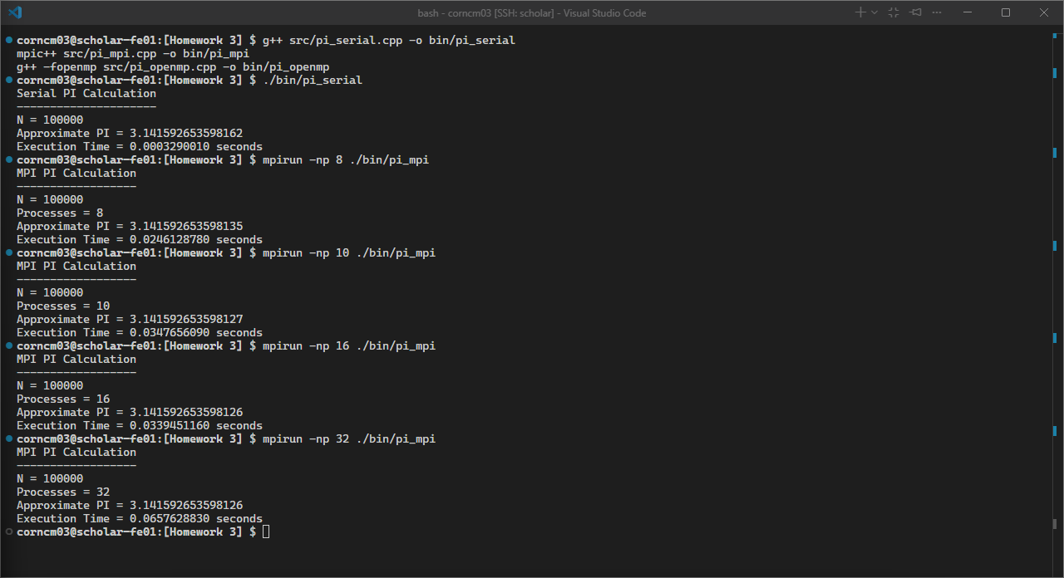
Figure: Homework 03 Screenshot 06-Pi MPI 32 Run

OpenMP Execution

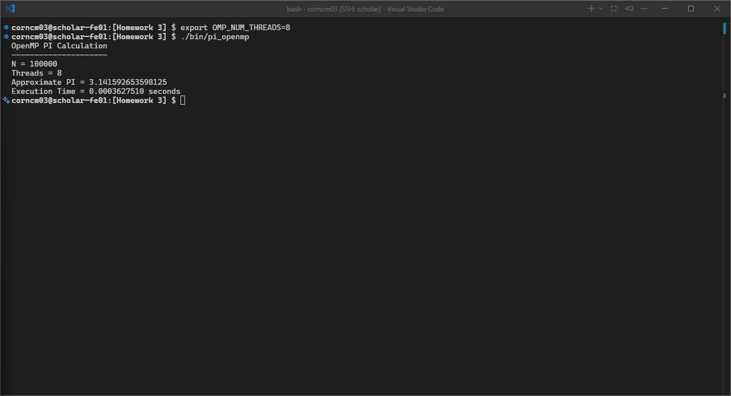
Figure: Homework 03 Screenshot 07-Pi OpenMP 8 Run

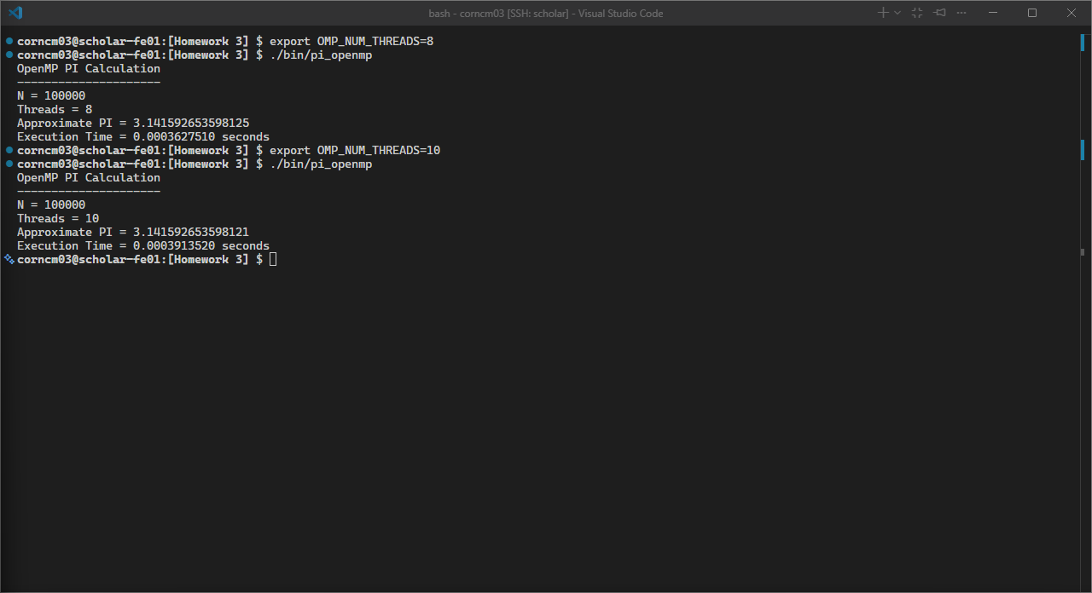
Figure: Homework 03 Screenshot 08-Pi OpenMP 10 Run

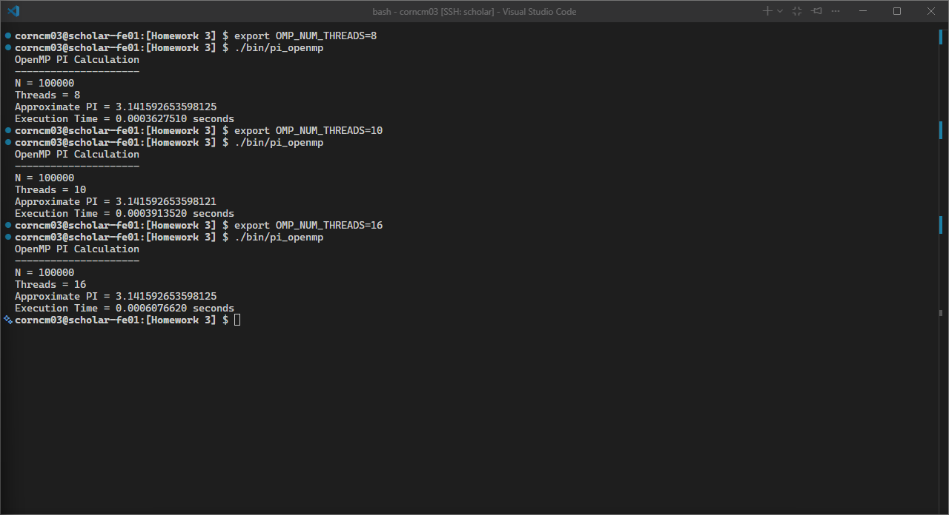
Figure: Homework 03 Screenshot 09-Pi OpenMP 16 Run

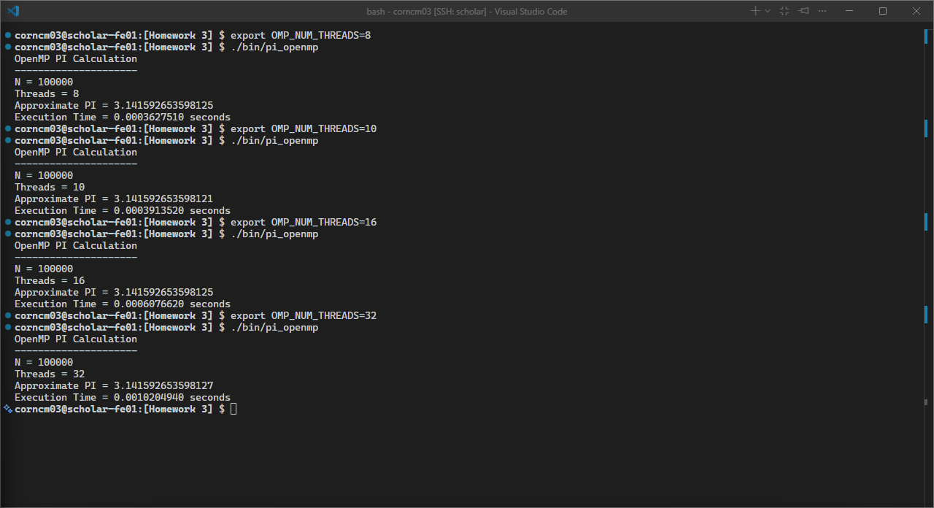
Figure: Homework 03 Screenshot 10-Pi OpenMP 32 Run

4. Timing and Speedup Results
Version | Processes/Threads | Time (seconds) | Speedup
Serial | 1 | 0.0003290010 | 1.0
MPI | 8 | 0.0246128780 | 0.0134
MPI | 10 | 0.0347656090 | 0.0095
MPI | 16 | 0.0339451160 | 0.0097
MPI | 32 | 0.0657628830 | 0.0050
OpenMP | 8 | 0.0003482320 | 0.9448
OpenMP | 10 | 0.0003913520 | 0.8407
OpenMP | 16 | 0.0006076620 | 0.5414
OpenMP | 32 | 0.0010204940 | 0.3224

5. Discussion
I expected the parallel versions to perform better than the serial version, but the results showed that the serial version was actually faster for this problem size.
I think this happened because N = 100,000 is relatively small, so the actual computation finishes very quickly. The overhead of creating MPI processes and OpenMP threads ends up taking more time than the computation itself.
For MPI, performance got worse as I increased the number of processes. This makes sense because more processes means more communication and synchronization overhead, especially when the workload per process becomes smaller.
OpenMP performed better than MPI, but it still did not outperform the serial version. This helped me understand that shared-memory parallelism has less overhead than distributed-memory parallelism, but still has some cost when creating and managing threads.
Overall, this assignment showed me that parallel programming is not always faster, especially when the problem size is too small to benefit from it.

6. Conclusion
From this assignment, I learned how to implement parallel programs using both MPI and OpenMP, and how to measure and compare their performance.
I also learned that overhead plays a big role in parallel computing, and that increasing the number of processes or threads does not always lead to better performance.

